## CHAPTER - 1

## INTRODUCTION

# INTRODUCTION

The process of examining a company's performance in relation to its commercial and financial environment in order to make a choice or make a suggestion is known as financial analysis. Financial analysts' actions and ideas are often driven by the desire to make money for corporations, including whether or not to examine a company's debt or equity instruments, and at what price.

The investor in debt securities is worried about the company's capacity to pay interest and return the principal. A stock capitalist is a shareholder with a residual interest in a company who is worried about the firm's capacity to pay dividends and the prospective value of its shares.

The purpose of financial statement analysis is to identify patterns and correlations between components of financial statements. Internal management as well as external customers of financial accounts (such as analysts, lenders and investors) must evaluate company earnings, liquidity and solvency.

Trend analysis, general volume data and ratio analysis are the most popular methods of financial analysis. Results and calculations and comparisons of past business information, competitors or trading averages are used to determine a company's relative strength and performance.

The information discovered in the financial accounts of a corporation serves as the foundation for a basic financial analysis. Audited financial statements, extra disclosures needed by regulators, and any (unaudited) management statement are all included in these financial statements. The fundamental budget analyses described in this reading give analysts a framework for better understanding alternative data derived from research other than financial statements.

Allow analysts to analyze financial and other reporting data, as well as financial statements, notes and management comments, company performance and financial status. An Associate Analyst is a financial analyst who evaluates equity securities, assesses credit risk, pays appropriate attention to purchases, and analyzes affiliate performance compared to other business entities.

The examination of the company's financial state, capacity to create profits and revenue, and the potential for profit and future revenue growth are the important topics in each equity and credit analysis.

Financial analysis is used to help with financial planning and decision-making. The balance sheet and profit and loss account, among other final accounts, offer essential financial information for decision-making. To examine, compare, and evaluate a company's revenue potential, financial reports are necessary.

The profit and loss account is the preferred operational activity, and the balance sheet value of the assets and liabilities acquired throughout is shown in the second statement. Management, lenders, investors, and others use the information in these statements to make choices regarding the company's management performance and financial situation.

Users of financial statements, if they properly examine the data in these statements, will gain any insight into the financial strengths and limitations of the company. Management should be very interested in learning about the financial strengths of the organization so that they can be utilized to the fullest extent possible, as well as take appropriate remedial action by identifying the financial shortcomings of the organization.

The company's future goals should be determined by the company's financial strengths and limitations, as well as Hero Motor's financial strengths and weaknesses. Before applying any complex assessment and planning processes, it is a starting point to develop financial analysis plans. Understanding the past may be necessary to predict the future.

# THEORETICAL BACKGROUND OF THE STUDY

**Financial Statement analysis**

Financial analysis has existed as an independent function and as part of other activities inside the organization from the beginning of financial performance, and it first arose in the 1900s while performing field studies utilizing analysis in the study of the financial position of company. Financial analysis was first utilized in the United States in 1900, when a study of 981 enterprises was done to analyze their financial situation using seven financial variables.

Financial analysis is often the foundation of employment development. It also acknowledged changes in finance and accounting functions, which altered the submission norm that governed financial and accounting operations until after WWII, when they became an essential element of management. Independent economics course offered at financial and business-related institutions and academies.

Financial analysis is divided into two categories: financial analysis and quantitative analysis. In general, analysis is the process of looking at a situation and determining its defects and strengths.

The introduction of a ratio defines "the relationship between two variables or characteristics that have a common condition or comparable circumstance" as "a relationship between two variables or features that share a common characteristic or similar situation." Its goal, however, is to build linkages between two accounting variables with comparable associations or qualities in order to study a specific circumstance.

If the research is passed on through the generations. The notion of quantitative analysis is said to have been adopted in the second half of the twentieth century as a consequence of the development in economic functions in business and financial decision making.

Quantitative analysis, on the other hand, is a technique that employs quantitative methods to analyze the miracles or exercises that businesses perform, as well as to establish collaborations between variables that control the exercise and conclusions to manage events such as investments, loans, and financing. Portfolios and other applications are available.

Financial Statement Analysis is a technique for analyzing and assessing a company's accounting reports (financial statements) in order to evaluate its past, present, and future performance. Making more lucrative judgments is feasible thanks to the approach of monitoring financial accounts. Privately held businesses are obliged by law to file financial reports with the appropriate authorities.

Financial statements must be filed with the Securities and Exchange Commission by representative firms that conduct business publicly in the United States (SEC). Companies are under pressure to incorporate their financial statements in their quarterly shareholder reports. Although financial statements are suited to the situation, another phase in the process is to properly break them down so that future profitability and cash flows may be projected.

The fundamental purpose of financial statement analysis is to estimate how other business operations will perform in the future using data from other company activities. Another important purpose of financial report analysis is to identify and fix underlying issues.

Financial analysis is the process of assessing a company's financial strengths and weaknesses by establishing a strategic link between its balance sheet, profit and loss statement, and other operational statements.

Therefore, financial analysis is an attempt to divide financial statements into their parts based on the objective at hand and on the one hand to identify the relationship between the individual components and the sum of these matters. Trends in a number of key areas over the past few years have also been studied to change the profitability and financial position of the corporate entity.

**There are three main stages in the analysis of financial statements:**

The first step is to rearrange all of the financial statements that make up the financial statements. Based on the appendices and appendices, it disassembles the elements of personal financial statements and reassembles them into several primary components. As a consequence, the balance sheet and profit and loss account have been totally changed and are now provided in a different, shortened format than before. The next phase is to develop strong links between the balance sheet and the various profit and loss account components. Financial analysis techniques such as the general ledger, ratio analysis, trend analysis, and money flow data are used to do this. Finally, the significance of the outcomes achieved via the usage of financial tools is evaluated.

**The value of financial analysis**

Financial analysis is the highlighting of important facts and related links Managerial performance, the organization's efficiency, financial strengths and weaknesses, and the company's creditworthiness.

Analytical tools are used to examine accounting data to determine the stability of operating procedures, company investment value, credit ratings and operational efficiency. In order for a company to make reasonable judgments, the finance manager must be well versed in various methods of analysis.

These analytical tools are very useful for the planning and control tasks of the Finance Manager. When formulating the financial plan of a company, the financial manager should take into account the impact of the financial decisions he makes on the financial position and profitability of the company.

Financial analysis techniques may assist management in evaluating the success of their activities in the same way that they might if they were done manually. These approaches are especially valuable in the area of financial regulation because they enable the financial management to compare the real financial operations of the whole firm and its many divisions to the performance of the balance sheet and profit and loss statement. Determines the source of significant variances and takes remedial action if warranted. As a result, the finance manager can defend his decisions and easily attain the firm's aim by employing financial analysis tools.

* Financial managers alone cannot benefit from financial analysis tools. It benefits top management, lenders, investors and workers.
* The top management company can assess the success or failure of operations, determine the relative efficiency of different departments, processes and products, evaluate individual performance and evaluate the control system by evaluating and interpreting financial information.
* For analytical tasks, not all methods need to be used. Tool selection is strongly influenced by the target at hand. Due to differences in the specific interests of analysts, the strategy that one analyst regularly uses may not be as valuable to other analysts.

**FINANCIAL ANALYSIS PROCESS**

1. Identify the industry economic features

To get started, choose to examine a company's value chain - a chain of processes related to the creation, development, assembly and delivery of company goods and components. Examples of methods At this stage, Porter's Five Forces investigations or monetary property investigations are often used.

2. Determine company strategies

Next, look at the type of product / company the company offers, including product specificity, payment margin estimation, brand name stability and cost control. Factors such as inventory system solution, spatial expansion and growth of industries should also be considered.

3. Evaluate the company's financial statements

Consider key cost charts in the context of creating reasonable accounting models. Accurate evaluation requires issues such as confirmation, value and description when examining fund-related record accounts. The main question is whether this accounting report provides a complete picture of the financial condition of the appendix. When examining the definition of payment, the most important thing to remember is to evaluate the concept of utility as a complete picture of the financial implementation of the supplement.

Analysis of cash flow statements helps to determine the liquidity status of a subsidiary, its impact on cash operations over time, estimates and actions, as well as where the components originated and where they went and how the overall liquidity of the company is affected.

4. Evaluation and analysis of profitability and current losses

This is where financial experts make a real difference to company value and cost reporting. The main ranges of cash loss associated with liquidity, liability assets, profitability, board / foundation commitment and risk / offer value are frequently considered.

In terms of efficiency, there are two broad questions to ask: how useful are business policies in terms of their merits — regardless of how well the company supports those pivot points — and how productive the company is from the point of view of respected speculators.

It is also important to understand how actions that return to a primary impact are categorized on a case-by-case basis as a whole and compare with points from different periods or between different affiliates or industry.

5. Prepare expected financial statements

Although budget experts generally test, they must make acceptable predictions about the future of the company (and industry) and choose how these uncertainties will affect cash flows and financing. This is often expressed as a summary of typical costs for professionals, with methods such as a percentage-offer approach being offered.

6. Estimating company value

Although there are many approaches to valuation, the most obvious may be a substantial discount payment method. This cash flow may be in the form of expected benefits or through strategies such as free cash flow to discreet owners or on an affiliate basis and regularly. Different systems can collaborate using linked valuation or accounting-based analytics, for example, despite financial constraints.

**USERS OF FINANCIAL STATEMENTS ANALYSIS**

Individuals from many walks of life employ financial statement analysis. Separating internal and external users is possible. Internal customers are members of the company's management who analyze financial statements in order to make operational decisions. External clients are not firm workers, although they do have a financial interest. Employers, investors, creditors, the government, employees, customers, and the general public are among them. The development level of these users is less than one.

Financial statement analysis is used by company leaders to offer information about their performance. They may, for example, utilize their account information to calculate the price or the amount of cash remaining in each distribution channel, and then design displays depending on the findings.

2. The proprietors

Small business entrepreneurs need financial data from their operations in order to determine if their firm is profitable. It helps in making choices such as whether to keep the firm open, improve business processes, or shut it down entirely.

3. Investors

Investors who purchase stock in a firm want financial data in order to comprehend how the company's success is measured. Financial statement analysis is used by investors to decide what to do with their company's investment. Investors will own, sell, or acquire more shares based on the company's success.

4. Lenders

Lenders want to know if the company can pay off its obligations or debts when they are in arrears. Lenders analyze the company's financial records for cash flows to determine the company's liquidity or ability to make short-term payments.

5. Government

Financial statement analysis is commonly used by government and government regulatory agencies to understand how the economy works so that they can plan their financial and industrial activities. The appraisal officers also examine the company's financial accounts to determine what kind of tax burden the company should bear.

6. Employees want to know if their jobs are safe and if they have a chance to make more money. Employees want to know the profitability and stability of their company. Employees are interested to know about the financial condition of the company to find out if there are plans for development and consequently business opportunities.

7. Customers

Customers need information about the company's ability to serve them in the future. If the customer (e.g., supplier of technical goods) relies entirely on the company for its inventory, the need to know the operational stability of the organization is very high.

8. Generally public

Analysis of company financial statements can be useful to any of the general public such as students, analysts and researchers. They may want to calculate the impact of the work on the environment, surroundings or perhaps the whole area. For example, if a company is conducting business social responsibility programs to improve the neighborhood, people will be concerned about the future activities of the company.

**KINDS OF FINANCIAL ANALYSIS**

1. Internal evaluation

The Chief Guidance Officers do the internal analysis with the help of the Management Accountant. The financial and accounting department of the company has immediate access to all relevant financial documents. The relevant study focuses on the overall performance and compliance of the organization and the assessment of the profitability of the various activities.

2. Short-term analysis

Short-term scrutiny of financial statements is the analysis of working capital to assess future returns, the ability to pay interest, the majority of debt - current and long-term and the potential for a good dividend policy.

The company has enough cash to meet its current needs and the ability to borrow enough to cover emergencies. In this regard, the liquidity status of a company is assessed by examining current assets and current liabilities. As a result, ratio analysis is widely applicable to short-term analysis.

3. Long-term evaluation

A minimum return on investment is required. It is necessary to pay for the growth and development of the company as well as capital expenditure. Financial planning is also crucial to a company’s long-term success. In long-term analysis, fixed asset structure, leverage analysis, model of securities ownership and similar calculations are made.

4. Horizontal Analysis

Dynamic analysis is another name for this. Horizontal analysis is often defined as the examination and division of financial accounts. This form of analysis is derived from the approximate development.

5. Perform vertical analysis

Consonant analysis is another name for this. In this type of study the ratios are taken using a one-year balance sheet and / or one-year profit and loss account. It can only be used for short-term analysis.

**This project has given a summary of financial analysis.**

Financial reports are primarily used to generate data and to understand a company's financial position and performance, as well as earnings and cash flow. The analyst may study the company's financial situation and performance, as well as trends in that performance, using the information provided in the reports, which includes financial statements, descriptions, and analyses.

* A statement of financial position (i.e. balance sheet), a statement of comprehensive financial returns (or both statements of a partner and a statement of comprehensive income press release), a statement of changes in equity, and a statement of cash flows are all included in preliminary financial statements.
* The record shows what resources the organization has (assets) and what it owes (debts) at any one moment (liabilities). Equity is a claim on a company's net assets after the owners' residual part of the company's assets or liabilities have been removed. Liabilities + equity = assets is the equation that indicates the link between the three parts of the record (assets, liabilities, and equity).
* The statement shows the financial outcomes of the company's business activity over a specific time period. The income statement reveals the company's revenue and other financial gains over time, as well as the costs and losses it experienced in the process of obtaining those revenues and profits. Income + other financial gain - costs = profits is the fundamental equation that underpins advertising.
* Except for transactions with the homeowners, any comprehensive financial gains that affect the homeowners' equity will be included in the declaration. The majority of these are covered by earnings, while some are covered by OCI.
* The notification of changes in equity informs investors about whether the different components of equity will rise or fall.
* Despite the fact that statements and records are markers of corporate performance, the firm need a significant amount of money and sales to be successful in the long run. Lenders, investors, and other data users may analyze a company's liquidity, solvency, and cash availability by disclosing its financing sources and uses.
* Financial statement notes (also known as margins) are crucial information in these documents and give the facts required to comprehend them. Different accounting techniques, estimations, and estimates should be exposed to analysts.
* The corporation offers a lot of important information tools for analysts in addition to financial reports. As part of his or her study, the analyst must evaluate and assess these extra facts, particularly those provided in the management note (also known as management report, activity and financial review and management discussion and analysis [MD&A]).
* An independent auditor must audit a publicly listed company's yearly financial statements. The auditor's report offers input on financial statements and some confidence that they correctly reflect the company's financial situation, performance, and cash flow. For corporations that trade publicly in the United States, auditors should also score peer judgments on corporate regulatory systems.
* When it comes to maintaining track of a company's financial performance, context, and assessing the company's future, information about the economy, industry, and comparable firms may be valuable. In most situations, data from external sources inside the corporate unit area is critical to assistant analysts' success.
* The financial analysis framework lays forth procedures that may be used in any budgeting effort. These are the steps:
* Collect input data;
* Articulate the purpose and context of the analysis;
* Analyze/interpret the processed data;
* Process data;
* Follow up.
* Develop and communicate conclusions and recommendations; and

**IMPORTANCE OF THE TOPIC**

* Assess the operational efficiency and management impact of the company.
* Examine the financial strengths and weaknesses of the organization and its creditworthiness.
* Examining the status of the current financial analysis,
* Determine the different types of assets belonging to the company and the liabilities to be paid to the company.
* Provide information on the company's cash position in proportion to equity and the corresponding loan amount.
* Examine company inventory and debts in terms of rationality.
* Financial analysis, when conducted internally, can assist fund managers in making future company choices or reviewing historical models of past successes.
* External financial research may assist investors in selecting the finest prospective investment possibilities.
* The two basic forms of financial analysis are basic analysis and technical analysis.
* Ratios and financial report data are used in the preliminary analysis to assess the inherent value of security.
* Technical analysis considers the value of security as having already determined its value and instead focuses on price models over time.

**ANALYSIS OF FINANCIAL CONDITIONS**

As each organization becomes digital, this decision-making process must gather the latest information in today's world. It improves profitability, company value and cash flow by providing in-depth information about the financial condition of the company. It helps in improving the ultimate goals of the organization, as well as in the decision making process.

The items listed below are required for financial analysis.

* Revenue Statements: The complete balance sheets and income statements reflect profit, loss, and prospective profit. In this context, liabilities, assets, capital, debt position, and other financial indicators are critical for budgeting, planning, and profitability.
* Working Capital Statement: A financial examination of the past / current year's current assets, liabilities, and working capital statements discloses all cost and working capital swings. Budgeting, assessment, and strategic planning all benefit from it.
* Comparative Data: You may use this research to compare and contrast the present situation of the industry with data on volume exposure from a variety of firms.
* Ratio Analysis (Ratio Analysis): It's a great tool for your business, with applications including asset management, liquidity, debt management, market value, financial performance of different sectors, and business sector profitability.

# INDUSTRY PROFILE

The automobile industry has changed the way people live and work. The earliest of modern cars was manufactured in the year 1895. Shortly the first appearance of the car followed in India. As the century turned, three cars were imported in Mumbai (India). Within decade there were total of 1025 cars in the city. The dawn of automobile actually goes back to 4000 years when the first wheel was used for transportation in India. By 1600s small steam-powered engine models was developed, but it took another century before a full-sized engine-powered vehicle was created. Brothers Charles and Frank Duryea introduced the actual horseless carriage in the year 1893. It was the first internal-combustion motor car of America, and it was followed by Henry Ford's first experimental car that same year. One of the highest-rated early luxury automobiles was the 1909 RollsRoyce Silver Ghost that featured a quiet 6-cylinder engine, leather interior, folding windscreens and hood, and an aluminum body. Chauffeurs usually drove it and emphasis was on comfort and style rather than speed. During the 1920s, the cars exhibited design refinements such as balloon tires, pressed-steel wheels, and four-wheel brakes. Graham Paige DC Phaeton of 1929 featured an 8-cylinder engine and an aluminum body. The 1937 Pontiac De Luxe sedan had roomy interior and rear-hinged back door that suited more to the needs of families. In 1930s, vehicles were less boxy and more streamlined than their predecessors. The 1940s saw features like automatic transmission, sealed-beam headlights, and tubeless tires. The year 1957 brought powerful high-performance cars such as MercedesBenz 300SL. It was built on compact and stylized lines, and was capable of 230 kmh (144 mph). Modern cars are generally light, aerodynamically shaped, and compact. 38 A Study of Analysis of Market Strategies in Automobile Companies in India GROWTH OF AUTOMOBILE INDUSTRY IN INDIA Following India's growing openness, the arrival of new and existing models, easy availability of finance at relatively low rate of interest and price discounts offered by the dealers and manufacturers all have stirred the demand for vehicles and a strong growth of the Indian automobile industry. The Indian auto industry, worth US$ 34 billion in 2006, has grown at a CAGR of 14 per cent over the last five years with total sales of vehicles reaching around 9 million vehicles in 2005-06. That number is likely to see a significant boost, given that the first half of 2006-07 has already witnessed a staggering growth rate of 17.12 per cent. Domestic car sales for the April-September 2006 period stood at an impressive 4.86 million vehicles, including cars, two-wheelers and commercial vehicles. According to industry experts, if this trend continues, sales could touch 10 million by March 2007, clocking an annual growth rate of 20 per cent. STATUS IN INDIA India is on every major global automobile player’s roadmap, and the reasons for the growth are:

• India is the second largest two-wheeler market in the world

• Fourth largest commercial vehicle market in the world

• 11th largest passenger car market in the world

• Expected to be the seventh largest by 2016 38

**Automotive Research Association of India and standards**

The [Government of India](https://en.wikipedia.org/wiki/Government_of_India) felt the need for a permanent agency to expedite the publication of standards and development of test facilities[[159]](https://en.wikipedia.org/wiki/Automotive_industry_in_India#cite_note-159) in parallel with the work of the preparation of the standards - as the development of improved safety critical parts could be undertaken only after the publication of the standard and commissioning of test facilities. The [Ministry of Surface Transport](https://en.wikipedia.org/wiki/Ministry_of_Surface_Transport) (MoST) constituted a permanent [Automotive](https://en.wikipedia.org/wiki/Automotive_industry) Industry Standards Committee (AISC) . The Standards prepared by AISC will be approved by the permanent CMVR Technical Standing Committee (CTSC). After approval, the [Automotive Research Association of India](https://en.wikipedia.org/wiki/Automotive_Research_Association_of_India) (ARAI)[[160]](https://en.wikipedia.org/wiki/Automotive_industry_in_India#cite_note-160) will publish this standard.

[Intelligent Transport Systems](https://en.wikipedia.org/wiki/Intelligent_transport_systems) (ITS) are globally proven systems to optimize the utilization of existing transport infrastructure and improve transportation systems in terms of efficiency, quality, comfort and safety. Having realized the potential of ITS, Government bodies and other organizations in India are presently working towards implementing various components of ITS across the country.

The first step taken for creation and implementation of ITS was holding a National Workshop titled "User Requirements for Interactive ITS Architecture",[]](https://en.wikipedia.org/wiki/Automotive_industry_in_India#cite_note-161) which was conducted as a collaboration between SIAM and ASRTU on 26 & 27 February 2015. This was primarily focused on ITS in [Public Bus Transportation](https://en.wikipedia.org/wiki/Bus). Nonetheless, the workshop helped to create the outline for "National Intelligent Transport System Architecture and Policy for Public Transport (Bus)", which was submitted by ASRTU and SIAM to the government

In the 44th & 45th CMVR-TSC, Chairman had directed - standardization activities to be initiated on Intelligent Transportation Systems (ITS) - [Vehicle Location Tracking](https://en.wikipedia.org/wiki/Location), [Camera](https://en.wikipedia.org/wiki/Camera) Surveillance System and [Emergency Request Button](https://en.wikipedia.org/wiki/Panic_button). The committee intended to extend the above user requirements to all public transportation namely –buses, taxis, etc. The current document covers the requirements for Vehicle Location Tracking and Emergency Button. The other ITS components like PIS, CCTV system, Fare collection etc. are deliberated and would be addressed in later phase and could be added as separate parts to the current document]

Based on these directions, the AISC Panel on ITS has prepared this AIS-140 titled,"[Intelligent Transportation Systems](https://en.wikipedia.org/wiki/Intelligent_transportation_system) (ITS) - Requirements for [Public Transport](https://en.wikipedia.org/wiki/Public_transport) Vehicle Operation". The panel also deliberated and identified the necessary elements for an effective implementation of vehicle level ITS system.

For AIS-140 Devices, in [India](https://en.wikipedia.org/wiki/India), connectivity to report location, and Emergency [Panic Button](https://en.wikipedia.org/wiki/Panic_button) signal is though wireless [cellular connectivity](https://en.wikipedia.org/wiki/Cellular_network). There are device focused Cellular Connectivity Offerings like 'eSIM4Things' available in India, which cater to connectivity requirements of AIS-140 devices. eSIM4Things is fully compatible with all AIS-140 devices and with a connectivity manager and a range of tariff plans.

Slow export growth[[edit](https://en.wikipedia.org/w/index.php?title=Automotive_industry_in_India&action=edit&section=7)]

Exports were slow to grow. Sales of small numbers of vehicles to tertiary markets and neighbouring countries began early, and in 1987 Maruti Suzuki shipped 480 cars to Europe ([Hungary](https://en.wikipedia.org/wiki/Hungary)). After some growth in the mid-nineties, exports once again began to drop as the outmoded platforms provided to Indian manufacturers by multinationals were not competitive.[[13]](https://en.wikipedia.org/wiki/Automotive_industry_in_India#cite_note-13) This was not to last, and today India manufactures low-priced cars for markets across the globe. As of 18 March 2013, global brands such as [Proton Holdings](https://en.wikipedia.org/wiki/Proton_(automobile)), [PSA Group](https://en.wikipedia.org/wiki/PSA_Group), [Kia](https://en.wikipedia.org/wiki/Kia_Motors), [Mazda](https://en.wikipedia.org/wiki/Mazda), [Chrysler](https://en.wikipedia.org/wiki/Chrysler), [Dodge](https://en.wikipedia.org/wiki/Dodge) and [Geely Holding Group](https://en.wikipedia.org/wiki/Geely_Holding_Group) were shelving plans for India due to the competitiveness of the market, as well as the global economic crisis.[[14]](https://en.wikipedia.org/wiki/Automotive_industry_in_India#cite_note-14)

Emission norms

In 2000, in line with international standards to reduce vehicular pollution, the central government unveiled standards titled "India 2000", with later, upgraded guidelines to be known as [Bharat Stage emission standards](https://en.wikipedia.org/wiki/Bharat_Stage_emission_standards). These standards are quite similar to the stringent [European emission standards](https://en.wikipedia.org/wiki/European_emission_standards) and have been implemented in a phased manner.

[Bharat Stage IV](https://en.wikipedia.org/wiki/BS_IV) (BS-IV), the most stringent so far, was implemented first, in April 2010, in 13 cities—[Delhi](https://en.wikipedia.org/wiki/Delhi) (NCR), [Mumbai](https://en.wikipedia.org/wiki/Mumbai), [Kolkata](https://en.wikipedia.org/wiki/Kolkata), [Chennai](https://en.wikipedia.org/wiki/Chennai), [Bangalore](https://en.wikipedia.org/wiki/Bangalore), [Hyderabad](https://en.wikipedia.org/wiki/Hyderabad,_India), [Ahmedabad](https://en.wikipedia.org/wiki/Ahmedabad), [Pune](https://en.wikipedia.org/wiki/Pune), [Surat](https://en.wikipedia.org/wiki/Surat), [Kanpur](https://en.wikipedia.org/wiki/Kanpur), [Lucknow](https://en.wikipedia.org/wiki/Lucknow), [Solapur](https://en.wikipedia.org/wiki/Solapur), and [Agra](https://en.wikipedia.org/wiki/Agra)—and then, as of April 2017, the rest of the nation.

In 2019, in line with international standards to reduce vehicular pollution, the central government of India announced the introduction of [BS-VI norms](https://en.wikipedia.org/wiki/Bharat_stage_emission_standards) to control air pollution, taking effect from 1 April 2020.

India levies an import tax of 125% on foreign imported cars, while the import tax on components such as gearboxes, airbags, drive axles, is 10%. Therefore, the taxes encourage cars to be assembled in India rather than be imported as completely built units.

Sub-4-metre rule

In 2006, the government of India imposed a new tax structure, which massively impacted the segment. It enables vehicles shorter than 4.0 metres (157.5 in) to qualify for a significantly lower excise duty, which is 8 percent as opposed to 20 percent for longer vehicles. [Tata Motors](https://en.wikipedia.org/wiki/Tata_Motors) was the first to exploit the new tax structure, which redesigned the rear portion of the [Indigo](https://en.wikipedia.org/wiki/Tata_Indigo) sedan, dropping its length to 3,988 mm (157.0 in) and renamed it as the Indigo CS.[[18]](https://en.wikipedia.org/wiki/Automotive_industry_in_India#cite_note-18) The model became significantly cheaper, becoming one of the largest selling three-box cars in the country.[[19]](https://en.wikipedia.org/wiki/Automotive_industry_in_India#cite_note-19) Other manufacturers quickly adapted, which led to the release of the shorter [Suzuki Swift Dzire](https://en.wikipedia.org/wiki/Suzuki_Dzire), the new [Honda Brio Amaze](https://en.wikipedia.org/wiki/Honda_Amaze), and others.

The majority of India's car manufacturing industry is evenly divided into three "clusters". Around [Chennai](https://en.wikipedia.org/wiki/Chennai) is the southernmost and largest, with a 35% revenue share, accounting for 60% of the country's automotive exports, and home of the operations of [Heavy Vehicles Factory](https://en.wikipedia.org/wiki/Heavy_Vehicles_Factory), Engine Factory Avadi, [Ford](https://en.wikipedia.org/wiki/Ford_India_Private_Limited), [Hyundai](https://en.wikipedia.org/wiki/Hyundai_Motor_India_Limited), [Renault](https://en.wikipedia.org/wiki/Renault_India_Private_Limited), [Mitsubishi](https://en.wikipedia.org/wiki/Mitsubishi), [Nissan](https://en.wikipedia.org/wiki/Nissan_Motor_India_Private_Limited), [BMW](https://en.wikipedia.org/wiki/BMW_India), [Hindustan Motors](https://en.wikipedia.org/wiki/Hindustan_Motors), [Daimler](https://en.wikipedia.org/wiki/Daimler_AG), [Caparo](https://en.wikipedia.org/wiki/Caparo), [Mini](https://en.wikipedia.org/wiki/Mini_(marque)), [Citroën](https://en.wikipedia.org/wiki/Citro%C3%ABn) and [Datsun](https://en.wikipedia.org/wiki/Datsun).

Near [Mumbai](https://en.wikipedia.org/wiki/Mumbai), [Maharashtra](https://en.wikipedia.org/wiki/Maharashtra), along the [Chakan](https://en.wikipedia.org/wiki/Chakan,_Maharashtra) corridor near [Pune](https://en.wikipedia.org/wiki/Pune), is the western cluster, with a 33% share of the market. [Audi](https://en.wikipedia.org/wiki/Audi_India), [Volkswagen](https://en.wikipedia.org/wiki/Volkswagen_India), and [Škoda](https://en.wikipedia.org/wiki/%C5%A0koda_Auto_India) are located in [Aurangabad](https://en.wikipedia.org/wiki/Aurangabad,_Maharashtra). [Mahindra and Mahindra](https://en.wikipedia.org/wiki/Mahindra_and_Mahindra) has an SUV and engine assembly plant at [Nashik](https://en.wikipedia.org/wiki/Nashik). [General Motors](https://en.wikipedia.org/wiki/General_Motors_India_Private_Limited), [Tata Motors](https://en.wikipedia.org/wiki/Tata_Motors), [Mercedes Benz](https://en.wikipedia.org/wiki/Mercedes-Benz_India), [Land Rover](https://en.wikipedia.org/wiki/Land_Rover), [Jaguar](https://en.wikipedia.org/wiki/Jaguar_Cars), [Fiat](https://en.wikipedia.org/wiki/Fiat_Automobiles_India_Limited), and [Force Motors](https://en.wikipedia.org/wiki/Force_Motors) have assembly plants in the area.[[23]](https://en.wikipedia.org/wiki/Automotive_industry_in_India#cite_note-23)[[24]](https://en.wikipedia.org/wiki/Automotive_industry_in_India#cite_note-24)

The northern cluster is around the [National Capital Region](https://en.wikipedia.org/wiki/National_Capital_Region), and contributes 32%. [Gurgaon](https://en.wikipedia.org/wiki/Gurgaon) and [Manesar](https://en.wikipedia.org/wiki/Manesar), in [Haryana](https://en.wikipedia.org/wiki/Haryana), are where the country's largest car manufacturer, [Maruti Suzuki](https://en.wikipedia.org/wiki/Maruti_Suzuki), is based.

An emerging cluster is the state of [Gujarat](https://en.wikipedia.org/wiki/Gujarat), with a manufacturing facility of [MG Motors](https://en.wikipedia.org/wiki/MG_Motor_India) in [Halol](https://en.wikipedia.org/wiki/Halol), [Atul Auto](https://en.wikipedia.org/wiki/Atul_Auto) in [Rajkot](https://en.wikipedia.org/wiki/Rajkot), Ford, Oculus Auto in [Sabarkantha](https://en.wikipedia.org/wiki/Sabarkantha_district),Maruti Suzuki, and [Peugeot-Citroën](https://en.wikipedia.org/wiki/Groupe_PSA) plants are also planned for Gujarat.

[Uttarakhand](https://en.wikipedia.org/wiki/Uttarakhand) with [Tata Motors](https://en.wikipedia.org/wiki/Tata_Motors), [Telangana](https://en.wikipedia.org/wiki/Telangana) with [Hyundai](https://en.wikipedia.org/wiki/Hyundai_Motor_Company), [Ordnance Factory Medak](https://en.wikipedia.org/wiki/Ordnance_Factory_Medak), [Hyderabad Allwyn](https://en.wikipedia.org/wiki/Hyderabad_Allwyn) and [Mahindra & Mahindra](https://en.wikipedia.org/wiki/Mahindra_%26_Mahindra), [Noida](https://en.wikipedia.org/wiki/Noida) with [Honda](https://en.wikipedia.org/wiki/Honda_Siel_Cars_India), and [Bengaluru](https://en.wikipedia.org/wiki/Bengaluru) - [Karnataka](https://en.wikipedia.org/wiki/Karnataka) region with [Toyota](https://en.wikipedia.org/wiki/Toyota_Kirloskar_Motor), [Volvo](https://en.wikipedia.org/wiki/Volvo) and [Scania](https://en.wikipedia.org/wiki/Scania_AB), [Andhra](https://en.wikipedia.org/wiki/Andhra_Pradesh) with [Isuzu](https://en.wikipedia.org/wiki/Isuzu_Motors) and [Kia](https://en.wikipedia.org/wiki/Kia_Motors) and [Kolkata](https://en.wikipedia.org/wiki/Kolkata) - [Jamshedpur](https://en.wikipedia.org/wiki/Jamshedpur) belt also known as East India belt with companies such as [Hindustan Motors](https://en.wikipedia.org/wiki/Hindustan_Motors), [Heavy Engineering Corporation](https://en.wikipedia.org/wiki/Heavy_Engineering_Corporation), [Tata Hitachi Construction Machinery](https://en.wikipedia.org/wiki/Tata_Hitachi_Construction_Machinery), TIL Tractos, [Tata Daewoo](https://en.wikipedia.org/wiki/Tata_Daewoo) and [Tata Motors](https://en.wikipedia.org/wiki/Tata_Motors) are other automotive manufacturing regions around the country

## CHAPTER – 2

## REVIEW OF LITERATURE AND RESEARCH DESIGN

# REVIEW OF LITERATURE

Bay, Fadeville and Kamala (1995) conducted research on various companies and their financial performance. The main objective of the research is to find out the relationship between different companies and their financial success. For the purpose of the study, they selected seven large companies and studied the portfolio of different products (related and unrelated) and those with activities in various fields. Variations from company to company in financial performance and performance were calculated and statistically established during this research using a set of performance metrics / ratios. They observed that the various companies they saw had good financial results.

Samuel & Vanniyarajan (2007) used du-pont analysis to analyze the financial performance of a bank. They all agree that the liberalization of the financial industry in India has exposed Indian banks to a completely new financial climate with increased competition and new regulatory requirements. Banks in India and internationally have been able to explore expansion potential in India by launching new products for a wide variety of customer segments, many of which are not considered banking customers.

They suggested that banks should evaluate their performance and compare it with others. Finally, they concluded that the performance of banks can be assessed on the basis of three dimensions: structural, functional and efficiency factors, all of which are guided by the Association of Indian Banks.

Bhunia, Mukhuti, and Roy mention "Analysis of Financial Performance - Case Study" in their paper (2011). The major goal of this research is to determine the financial strengths and weaknesses of the two public sector pharmaceutical businesses listed on the BSE website. They must be chosen during the 1997-98 to 2008-09 study period. To investigate the data, they employed exploitation ratios as well as mathematical tools such as AM, SD, CV, multilinear regression analysis, and hypothesis testing.

Considering the strengths and threats, they used SWOT analysis to overcome vulnerabilities and seize opportunities for pharmaceutical companies and drugs that are traded publicly. They all agreed that the growth over the last decade has been phenomenal and that the market trend is expanding rapidly.

They said opportunities could be seized by diversifying export baskets for hitherto unused foreign markets. They also realized that the use of strict quality standards, services and cutting-edge technology would put them ahead of competitors around the world.

“Analysis of Financial Performance - A Case Study” by Bunya, Mokhote and Roy (2011). Analyzes in progress 3 (3): 269–275, Journal of Social Sciences, 2011.

Dr. Talent is a specialist in both religion and philosophy. Megha Mehta (Megha Mehta, Hero Megha Mehta, Hero Megha Mehta, Hero Megha Mehta, Hero Megha Mehta, Hero Megha Meh According to their analysis of car business financial performance, Hero Honda has succeeded well owing to its use of cutting-edge technology, but Tata Motors has performed poorly due to rising production overheads and an inability to compete.

Tariq Zafar and Khaled Ahmed's "Comparative Analysis of Maruti & Tata's Financial Performance and Market Value" (2012). They chose Maruti Suzuki Limited and Maruti Suzuki India Limited. In addition, there's Tata Motors Limited. For the goal of the research and the period of abuse 2006-2010.

They wanted to look at each company's qualitative and quantitative performance, as well as the combined influence of risk-return variables, market position, and profitability, in order to determine the best and worst performers using current performance evaluation tools. Then assigning them ranks based on their performance. For their investigative abilities.

They found a lack of credibility in the facts and accounts, which allowed the promoters to manipulate the display. It has been found that different companies use completely different accounting methods such as depreciation allowance, inventory value, etc. and management often ignores these differences when comparing companies. They observed that management did not adequately consider changes in price levels due to inflation.

According to Suvarun Goswami (2011), working capital is the lifeblood of a company. It is a type of capital that is needed to run a company on a daily basis and it varies depending on the nature of the company, production, sales policies, business turnover, etc ... Liquidity refers to the ability to change a company. Assets in monetary value. It assesses the ability of an organization to fulfill all outstanding responsibilities. No company can survive without liquidity. A company that is not profitable can be called unhealthy, but a company that does not have liquidity can quickly leave and be destroyed.

According to Arvind R (2013) Working Capital Management is the functional area of ​​finance that holds all company accounts. . It relates to the efficiency of current assets and the risk period caused by current liabilities.

He also thinks that the firm's working capital management techniques should be built to accomplish three goals: acceptable liability, risk reduction, and decrease in company value. The technique of assessing the connection between the components of a financial report in order to acquire a better understanding of the firm and its performance is known as financial statement analysis.

# STATEMENT OF THE PROBLEMS

Financial analysis is a method for systematically analyzing a company's financial situation. In order to examine and evaluate a company's financial strength, it's critical to note the information in its financial statement. There are several elements that might influence the manufacturing business, including corporate success and shareholder return.

It is quite tough to analyze a balance sheet in order to get a thorough picture of the financial statement. As a result, utilizing contemporary management systems, it is possible to get a precise financial statement. The investigation is carried out while keeping the division of challenges in mind and paying close attention to the financial statement of analysis of Bellad Motors Private Limited LTD.

Financial statement analysis and interpretation is a common practice for evaluating a company's performance. Every company's risk is rising every day, and the need for money to manage the firm is growing. As a result, every company must analyze its performance each year in order to maintain its market position. Ratios have shown to be an effective and strong analytical tool for assessing an organization's success. As a result, the performance of Hero Moto Corp Limited is investigated in this research.

# NEEDS OF THE STUDY

The study's primary goal is to examine Bellad Motors Private Limited financial performance and optimize the company's worth. This can only be accomplished via the flow of earnings, which are dependent on successful sales activity. In order to produce sales, sufficient cash must be invested in fixed and current assets.

Comparative statements, common size statements, and ratio analysis are the most frequent methods for financial analysis. Calculations and comparisons of the findings to past business information, rivals, or trade averages are used to determine the firm's relative strength and performance.

**Mainly the necessity of the study is:**

* To know the leverage position of the company.
* To know the liquidity position of the Bellad Motors Private Limited whether or not it's good or dangerous.
* To analyze ratio analysis.
* To find out financial position, development and issues of the company.
* To know the activity and gain position of the company whether or not good or dangerous.

The ratio analysis is another a part of ‘analysis of ratio of Bellad Motors Private Limited that is especially studied because it reveals what proportion money is generated from Bellad Motors Private Limited activities or operations activities and from finance and investment activities of Bellad Motors Private Limited, and it discloses all the movements of money and additionally discloses the success or failure of money coming up with. It additionally reveals the credit capability of the corporation and it's a measure of credit goodness. The higher than utilities of financial operations area unit necessary to form a study of financial operations of Bellad Motors Private Limited.

# SCOPE OF THE STUDY

The research is based on the financial position of Bellad Motors Private Limited as determined by ratio analysis, joint size statement and comparative data.

* The research and recommendations highlight the rules for the effective operation of the organization.
* This research will be more important and useful for the various parties dealing directly or indirectly with the company.
* Among other things, financial statements help management to analyze profits, solvency, liquidity and efficiency and provide an accurate picture of the company.
* The purpose of the research "Study on the Financial Analysis of Bellad Motors Private Limited" is to examine the financial performance of Bellad Motors Private Limited over the past five years.
* Research helps us to do financial research and make financial decisions in our lives.
* This research also helps management in making management judgments. These studies help managers understand new opportunities.

# OBJECTIVE OF THE STUDY

* To know schedule of change in the working capital.
* To analyze the profitability and liquidity position of the company.
* To analyze the financial strength and weakness of the company.
* To study the financial performance of Bellad Motors Private Limited Ltd.
* To compare the fund generated in Bellad Motors Private Limited for the past 5 years.
* To analyze the financial growth of the company.
* To analyze the fixed, current assets and current liabilities.
* To study the growth perspective of Bellad Motors Private Limited.

# SAMPLING

Research design used Analytical research design. To study the financial performance of 5 year data usage data collected from the report and accounts of Bellad Motors Private Limited (2017 to 2021) published under the regulation of companies and other regulatory bodies.

**Data Collection:** The study has been made with the help of information got from Two sources:

1. Primary sources.

2. Secondary sources.

**PRIMARY SOURCES**

A primary source mainly includes the information given by various lecturer, staff members and also through the discussions and orientation classes given by the faculty of the organization. The information got through personal observation also include in this.

**SECONDARY DATA**

Secondary sources mainly include the audited annual reports of Bellad Motors Private Limited which it re published, various annual manual of Bellad Motors Private Limited, through the journals, old records of Bellad Motors Private Limited. From these sources, necessary information is obtained. With the help of common statement, comparative statements, Ratio Analysis has been made

* From the annual reports maintained by the organization/company such as Statement of the profit and loss Balance sheets
* Books and journals pertaining to the topic.
* Data are collected from the company website.

# TOOLS FOR DATA COLLECTION

Various strategies or methods for reviewing and understanding a company's financial statements for a variety of reasons, such as planning, investment and performance, are referred to as financial analysis tools.

When the analyst, CEO or student is dealing with a financial problem or wants to understand the financial implications and financial transactions in business investments, activities or financing decisions, a wide variety of rarely used analytical methods and thumb rules are available. Create quantitative answers.

Consequently, selecting acceptable tools from the available options is an important part of the analysis process.

**The following are some of the tools used in financial analysis:**

* Ratio analysis
* Common size statements
* Trend analysis
* Comparative statements.
* Changes in financial position
* Cash flow statements

**In this project, we will look at:**

* Common size statements
* Comparative statements
* Ratio analysis

**DATA ANALYSIS**

**Comparative financial statements**

In a nutshell, Comparative Financial Statement Analysis is the practice of comparing financial statements from one year to the next. It enables the identification of weak regions and the implementation of therapeutic techniques. Two financial statements (balance sheet and income statement) are created in comparative form for analytical reasons.

**Comparative Balance Sheet**

The comparative balance sheet illustrates the company's various assets and liabilities on many dates so that the balances may be compared from one period to the next. On the comparative balance sheet, the data from the original balance sheet is separated into two columns. The third column shows how the numbers have changed over time (increased or decreased). To display the % rise and decline, a fourth column may be added. When reviewing a comparative balance statement, the translator should keep the following in mind:

* Long term financial position of the company profitability
* Current financial position and liquidity position of the company

When assessing a company's present financial situation or liquidity, it's crucial to look at its working capital over a two-year period. Working capital is the gap between current assets and current liabilities.

(ii) When examining the firm's long-term financial situation, fixed assets, long-term obligations, and capital fluctuations must all be taken into account.

(3) The third aspect to analyze in a comparative balance statement is company profitability. The analyst can assess if profitability has increased by looking at sales growth or reduction. The financial state of the company should be examined after looking at the different assets and liabilities.

Income Statement Comparison

The income statement displays the outcomes of the company's operations. This statement is known as trading and profit and loss A / c in the past. The revenue statement includes items like as net sales, product prices, sales expenditures, and office expenses. Individually, the top portions' values are compared to last year's comparable statistics, and discrepancies are indicated.

A comparative revenue statement shows how a company's performance has changed over time. Changes in financial value and percentage may be evaluated to determine a company's profitability.

The income statement has four columns, same as the comparative balance sheet. For two years, the first two columns show the number of distinct things. The third and fourth columns are used to show how the data has changed in terms of absolute sizes and percentages.

The following are examples of revenue statement analysis and interpretation:

* + To assess maintenance profitability, the rise or reduction in sales should be proportional to the increase or decrease in the price of the items sold.
  + The growth or reduction in net profit is computed to offer a sense of the company's overall profitability.

**Common Size statement**

In general volume assertions, analytical ratios are offered (balance sheet and income statement). Total assets, total liabilities, and percentage of total sales are used to convey these data values. Take, for example, the balance sheet. Each asset is given as a percentage and the total assets are set to 100. Similarly, the total liabilities encompass a variety of obligations.

**COMMON SIZE BALANCE SHEET**

The ratio of each asset to total assets and each obligation to total liabilities is specified in a standard size balance sheet. As a consequence, the following general volume statement is created.

Assume that your total assets and liabilities are 100.

Personal assets are computed as a percentage of overall assets (100), and liabilities are calculated as a percentage of total liabilities. For example, if total assets are 10,000 rupees and inventory is 100,000 rupees, inventory will be 10% of total assets.

10,000 x 100 = 900,000

**RATIO ANALYSIS**

Ratio is one of the most popular and widely used financial analysis tools. The coefficient of two mathematical expressions is technically defined as the "coefficient of two mathematical expressions". The relationship between two economic variables is the functional definition of the financial ratio.

In both vertical and horizontal analysis, the ratios are important. In vertical analysis, the ratios help the analyst to determine whether the company's performance over a period of time is excellent, questionable or poor.

Similarly, the use of ratios in horizontal analysis shows whether the financial health of a company improves or worsens over time and increases or decreases in cost, profitability or efficiency.

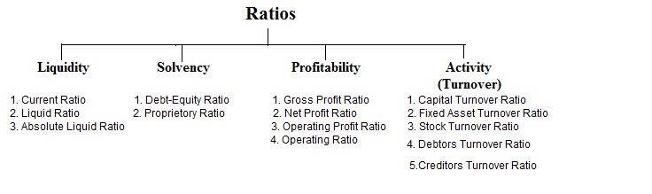

**There are two sorts of comparisons in ratio analysis:**

First, compare the current ratio with the past and projected future ratios for the same company. When calculating financial ratios over the previous several years, the analyst can assess the composition of the changes and whether the financial condition of the firm has improved or deteriorated over time.

The second comparison strategy is to compare an organization's ratios with those of comparable organizations or industry averages at the same period. Such a comparison will provide you with a wealth of information about the company's financial situation and performance.

**Types of Ratio Analysis**

Ratio analysis may be divided into four categories:

* Profitability Ratio
* Liquidity Ratios
* Solvency Ratio
* Activity Ratio
* **Liquidity Ratios**

Liquidity means readily available cash. It is a feature with which anyone can convert assets or security into cash without any effect on the market price. Any person or a firm can buy or sell an asset without any drastic change in the asset’s price. Therefore, liquidity ratio uses ratio analysis equations to help us to determine the short-term liquidity of a firm. There are two types of liquidity ratios.

Current Ratio: It gives us the idea of the short-term solvency of a firm.

Quick Ratio: It assists us in finding the solvency for six months.

* **Profitability Ratio**

This is the area where the actual business takes place. The profitability ratio is the one that finds out if the business being done fetches any profit or not. It measures the success of the business effectively over some time. The main profiteers of these ratios are the government, the tax holders, the stakeholders, and business owners. We all need a bank loan but we don’t know that before granting us the loan, the bank officials check the profitability status with the help of these ratios. Another key feature of profitability ratio analysis equations is that it judges the company based on its ability to generate profit.

* **Activity Ratio**

We can call it by another name i.e., turnover ratio. It is used for the estimation of the efficiency of the firm and for converting the product into cash. The activity ratio works on the basis of the duration of the days. It is of two types.

Inventory turnover ratio: Updates on the frequency of goods to be exchanged for cash. Inventory turnover ratio = price of goods sold / average inventory formula.

Acceptable turnover ratio: Information on the frequency at which credits are collected. Acceptable Turnover Ratio = Net Credit Sales / Acceptable Average Trading is calculated.

* **Solvency Ratio**

The solvency ratio examines the viability of a corporation and its capacity to repay long-term debt. There are two types of it under this.

Debt-to-Equity Ratio (DEFRA): A measure of the strength of a company's long-term financial policy. The principle is as follows:

Debt equity ratio = total liabilities / shareholder equity

Ownership Ratio: Assess the rigidity of a business's capital structure. The formula can be written as:

Propriety Ratio = Stakeholders Equity / Total assets x 100

**Limitations of Ratio Analysis**

Ratio Analysis is very useful for deriving the required information financially, however, it comes with its own set of limitations. Below are listed a few of the disadvantages of Ratio analysis–

* Historical data or inadequate data can cause misinterpretation of ratio analysis.
* Predictions on the future that depends on past trends may not always be reliable and correct,
* The analyst has to be well versed with the process in order to use ratio analysis.
* It may not always present an accurate picture since the data used is historical data.
* Ratio analysis can not be used in the case of comparison of different companies since every company has a different accounting practice with a different environment.

# LIMITATION OF STUDY

Although financial analysis has many advantages, it also has some disadvantages. Where the analysis is based on data presented in financial statements, it may be incorrect.

* The research was conducted over a period of five years, but it was not enough to examine every aspect of the work.
* Since the research is based on historical data, it cannot be trusted.
* When conducting a financial audit, companies often ignore price fluctuations. Companies do not provide an index for statistics when comparing data from different time periods. As a result, the company does not reflect the impact of inflation.
* The results of the study will not be applied to other organizations and the results of the study will not be used to assess the future financial status of the organization.
* Changes in company bookkeeping practices can often mislead financial analysts.
* Changes in price level are not taken into account.
* Financial statements are made on an ongoing basis and do not represent the current situation.
* Unregistered Incomplete assets Most invisible assets are not registered by companies. Instead, all costs incurred in creating the invisible property will be charged immediately.
* Companies only consider the monetary components of financial statements. It does not take into account non-monetary factors.
* Information collected for secondary research.
* Feedback is not always useful for predicting what will happen in the future.
* Analyzes and conclusions do not represent a broad perspective of the automotive industry. Instead, it specifically reflects Bellad Motors Private Limited.
* Financial statements are made based on historical expenses using financial values ​​of different dates. As a result, the impact of changing price levels is largely ignored.

## CHAPTER – 3

## PROFILE OF BELLAD MOTORS PRIVATE LIMITED AND RESPONDENTS

Bellad motors private limited is a private company, who was incorporated 31 year(s) 11 month(s) 4 day(s) ago on dated 11-jul-1990 . bellad motors private limited is classified as non-govt company and is registered at registrar of companies located in roc-bangalore. as regarding the financial status on the time of registration of bellad motors private limited company its authorized share capital is rs. 10000000 and its paid up capital is rs. 10000000.

As per registration of company, it involves under in business activity class / subclass code 50500, main activity of the said company bellad motors private limited is : , retail sale of automotive fuel [ includes the activity of petrol filling stations. this activity is often combined with sales of lubricating products, cleaning and all other kinds of products for motor vehicles. if the main object, however, is the sale of automotive fuel or lubricants, they remain classified here.], it comes under division sale , maintenance and repair of motor vehicles and motorcycles; retail sale of automotive fuel and this come under scetion wholesale and retail trade; repair of motor vehicles, motorcycles and personal and household goods.

Bellad motors private limited corporate identification number is u50500ka1990ptc011057 and its registration number is 011057 .its email address is emmarjee@gmail.com and its registered address is where company is actual registered : bellad chambers,vidyanagar,hubli hublidharwad, india 580031. for any query you can reach this company by email address or postal address.

Bellad motors private limited's annual general meeting (agm) was last held on mar 31, 2010 and as per records from ministry of corporate affairs (mca), its balance sheet was last filed on jan 01, 1900.

Bellad Automobile Private Limited is an unlisted private company incorporated on 04 August, 2005. It is classified as a private limited company and is located in Hubli., Karnataka. It's authorized share capital is INR 30.00 lac and the total paid-up capital is INR 1.00 lac.

Bellad Automobile Private Limited's operating revenues range is INR 1 cr - 100 cr for the financial year ending on 31 March, 2020. It's EBITDA has increased by 17.78 % over the previous year. At the same time, it's book networth has decreased by -0.50 %. Other performance and liquidity ratios are [available here](https://www.tofler.in/bellad-automobile-private-limited/company/U05010KA2005PTC036896/financials).

Description: This company is a authorized wholesale dealer of nissan micra, buses & corolla h2

The current status of Bellad Automobile Private Limited is - Active.

The last reported AGM (Annual General Meeting) of Bellad Automobile Private Limited, per our records, was held on 29 November, 2021. Also, as per our records, its last balance sheet was prepared for the period ending on 31 March, 2021.

Bellad Automobile Private Limited has three directors - [Mahesh Shivaputra Bellad](https://www.tofler.in/mahesh-shivaputra-bellad/director/01765920), [Prashanth Shivaputrappa Bellad](https://www.tofler.in/prashanth-shivaputrappa-bellad/director/01807670), and [others](https://www.tofler.in/bellad-automobile-private-limited/company/U05010KA2005PTC036896#overview_directors).

The Corporate Identification Number (CIN) of Bellad Automobile Private Limited is U05010KA2005PTC036896. The registered office of Bellad Automobile Private Limited is at BNESIDE HANS HOTEL,VIDYANAGAR,, HUBLI., HUBLI., Karnataka.

BELLAD GROUP was established in the year 1964 in the name of Bellad & Company by Mr.Chandrakant Bellad.  The Promoters are family members and closely held companies. All the partners are well experienced in this line of business. The group has diversified to various trading activities such as consumer home appliances, automobile business, power generation and distribution of lubricants. Presently, Mr. Chandrakant G. Bellad is the Chairman, Mr.Arvind Bellad – Managing Director & Mrs.Leelavati C. Bellad – Director respectively.

Shri Chandrakant G. Bellad, Smt. Leelavati C. Bellad & Mr. Arvind C. Bellad are the partners of the Bellad Group. Mr. Chandrakant G. Bellad father of Mr. Arvind C Bellad.  He is MLA of Dharwad Constituency and represented the constituency fourth time.  He is in the business for the last 46 years. Mrs. Leelavathi C. Bellad wife of Mr. Chandrakant G. Bellad.

**Our Vision**

“Bellad group will strive to excel by following highest standard of fairness, ethics and professionalism to create a sense of belongingness and commitment to its customers, employees, principals and business associates and contribute to the society and green revolution”

* Organizational Values
* We treat each other with trust, dignity, respect and follow highest standards of ethical behavior.
* Customer delight is our priority by being courteous, honoring commitments and delivering quality.
* We foster a spirit of innovation, knowledge sharing, teamwork & simplicity.
* We take accountability by delivering results and taking ownership for Bellad group’s overall success.
* We constantly support towards the well being of our society and environment.
* Retention of employees at all levels is our utmost priority.

Mr. Arvind C. Bellad the Managing Director of the firm. He holds PGDM in Business Management from Insead, France and a Bachelor of Engineering from Dharwad University, India. He is an active member in The Chamber of Commerce & Industries, Round Table and Federation of Automobiles Dealers (FADA).

He has joined the business in 1991, with only 18 employees and has been instrumental in expanding the Group’s Dealership Business. Most leading Automobile Manufacturers approached Mr. Bellad for Dealership looking at his entrepreneurial capabilities. Today under his leadership the Group has grown its business from a turnover of Rs.150 Crores in 1991 to Rs.400 Crores. While the major focus continues to be Automobile Dealership, he has also diversified the Group’s interest into other business into Electronic Appliances, Power Generation, Construction & Real Estate. His business goal is to grow the company’s Revenue to Rs.1000 crore turnover Group by 2018.

**SOCIAL WELFARE:**

Welfare Camps Every year we organize blood donation camps along with Red Cross, in which employees donate blood. Eye check-up camps, family planning related camps and other health camps are also organized periodically. Medical support & welfare The employees of Maruti have always donated generously to people affected by natural calamities. They contributed Rs. 2 million to rehabilitate earthquake victims in Latur. We also run a creche for the children of construction workers, which provides food shelter and education for 85 children. Education to underprivileged DPS Maruti Shiksha Kendra, an education programme for the underprivileged, was inaugurated at DPS, Maruti Kunj recently. The objective of his project is to educate the children of below poverty line (BPL) families from the nearby villages of Gurgaon district. 120 students in the age group of 5-8 years have already enrolled. DPS Maruti Kunj is providing books, writing material and uniforms, refreshment and transport facilities to these children. Belgaum Institute

**Education Programme for mothers 'Chetna',**

An education programme for mothers - is an another endeavour to provide basic education to mothers of the students of DPS Maruti Kunj and surrounding villages. Majority of students at the school is first generation learners. Therefore, the concept of starting a movement of learning 'Chetna' for mothers has been promoted. The response has been encouraging and about 130 mothers are attending it regularly.

**ENVIRONMENT CONCERN**

**Our environment Policy:**

• Prevent pollution.

• Promote energy reduction and use of alternative energy.

• Manage/ reduce those materials that put stress on environment.

• Promote the three R's (Reduce, Reuse, Recycle).

• Promote "Green" procurement.

• Provide our employees with environmental education to

increase their awareness.

Since the commencement of operations in 1981 we've been committed to the protection of

the environment and conservation of non-renewable .energy sources. Our proactive

approach depends not only upon meeting the expectations of the regulatory authorities but

achieving the high standards that we've set as a responsible corporate citizen.

# SWOT ANALYSIS OF BELLAD MOTORS

**STRENGTH**

1. Excellence in vehicle safety and design proven by many awards
2. The 6th highest automotive brand reputation in the world
3. Effective research and development (R&D) spending resulting in new innovative cars
4. Low cost to drive and durable cars
5. Strong presence in India’s market

**WEAKNESS**

1. Poor brand portfolio, leading to fewer sales
2. Low presence in the strongest Indian vehicle market and no presence in other country vehicle market
3. Declining quality of company’s management
4. Product recalls damaging brand reputation

**OPPORTUNITY**

1. Improving Indian economy
2. Timing and frequency of new model releases
3. Low fuel prices opening new markets for bellad motors

**THREATS**

1. Increased competition
2. Rising Company Won exchange rates
3. Increasing government regulations may raise the costs

## CHAPTER- 4

## DATA ANALYSIS AND INTREPRETATION

**DATA ANALYSIS AND INTREPRETATION**

**RATIO ANALYSIS**

**Current Ratio:**

The link between current assets and current liabilities is established by the current ratio. It tries to assess a company's capacity to satisfy present obligations. The following formula is used to calculate this ratio:

Current ratio = current assets / current liabilities

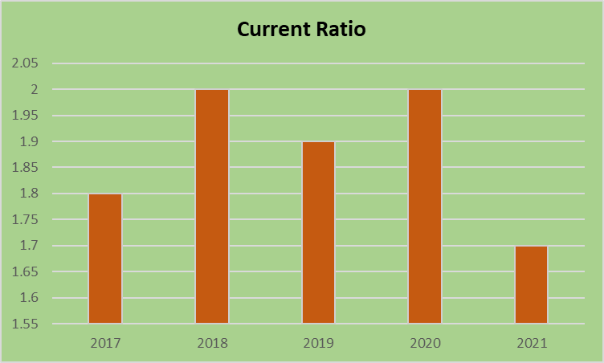 **Table 1: showing current ratio (in crores)**

|  |  |  |  |
| --- | --- | --- | --- |
| **Year** | **Current Assets** | **Current Liabilities** | **Current Ratio** |
| 2017 | 7453.18 | 4093.33 | 1.8 |
| 2018 | 8848.18 | 4343.32 | 2.0 |
| 2019 | 8115.64 | 4130.36 | 1.9 |
| 2020 | 8288.56 | 3976.06 | 2.0 |
| 2021 | 10952.79 | 6110.22 | 1.7 |

**INTREPRETATION:**

* According to the usual rule of current ratio 2:1, the performance of the current ratio in 2017 was 1.8 percent, and it increased to 2.0 percent in 2018, but declined to 1.7 percent in 2021.
* The current ratio is used to assess the connection between current assets and current liabilities.

**Liquidity Ratio:**

The liquidity ratio, usually known as the acid test or fast ratio, is a measurement of the quantity of liquid in a container. It is utilized in addition to the existing ratio. The acid test ratio is a more severe and demanding review of a company's ability to pay its short-term commitments on schedule. The liquidity ratio establishes the relationship between current commitments and liquid assets. The formula mentioned below is used to compute this ratio.

liquidity ratio = Current assets – (stock and prepaid expenses) /current liabilities

**Table 2. Showing Liquidity Ratio (in crores)**

|  |  |  |  |
| --- | --- | --- | --- |
| **Year** | **Quick Assets** | **Current Liabilities** | **Liquidity Ratio** |
| 2017 | 6796.87 | 4093.33 | 1.6 |
| 2018 | 8024.6 | 4343.32 | 1.8 |
| 2019 | 7043.27 | 4130.36 | 1.7 |
| 2020 | 7196.59 | 3976.06 | 1.8 |
| 2021 | 9483.24 | 6110.22 | 1.5 |

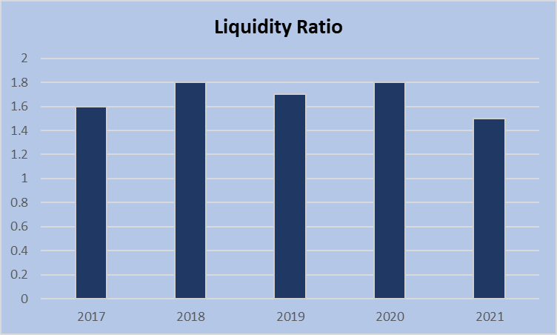

**INTREPRETATION:**

* The liquidity ratio 1:1. The above table that indicates the liquidity ratio of the company. In 2017 it was 1.6 and it has increased to 1.8 trends from 2018 to 2020. Then it decreased to 1.5 in the year 2021. A liquidity ratio 1:1 is considered to be satisfactory.
* The Liquidity Ratio of the firm is good

**CASH POSITION RATIO**

The cash ratio (also known as the cash asset ratio) is the amount of cash and cash equivalent assets a corporation has relative to its total liabilities. The cash ratio is a modification of the quick ratio that demonstrates how soon easily available money may be utilized to pay down current commitments. The most severe and cautious of the three liquidity requirements is the cash ratio (current, quick and cash ratio) (current, quick and cash ratio).

Cash position ratio= cash and bank balance \ current liabilities

**Table 3 showing cash position ratio**

**(In crores)**

|  |  |  |  |
| --- | --- | --- | --- |
| **Year** | **Cash and Bank Balance** | **Current Liabilities** | **Cash position Ratio** |
| 2017 | 136.73 | 4093.33 | 0.03 |
| 2018 | 141.34 | 4343.32 | 0.03 |
| 2019 | 136.46 | 4130.36 | 0.03 |
| 2020 | 241.86 | 3976.06 | 0.06 |
| 2021 | 257.15 | 6110.22 | 0.04 |

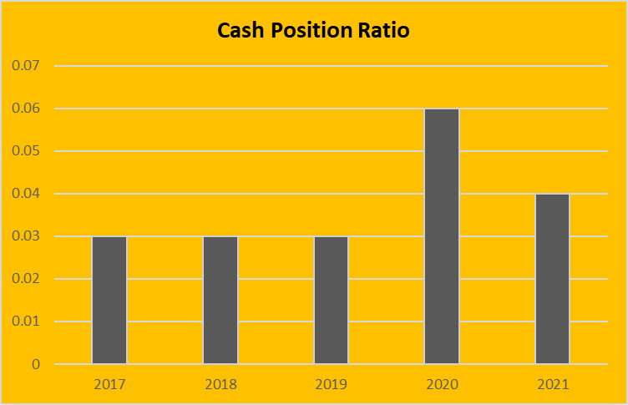

**INTREPRETATION**

* The Cash Position Ratio is the proportion of current assets to current liabilities. Between 0.2 and 0.5 is the optimum range.
* In the above table it shows cash position of the company in 2017 to 2019 remains constant it was 0.03 percentage and it has increased in 2020 with 0.06 percentage

**NET PROFIT RATIO**

The net profit ratio is also known as the profit margin ratio or the sales ratio from net profit. This ratio represents the overall capacity of the organization to execute its operations. The relationship between net profit (before or after taxes) and sales is calculated using the net profit ratio.

Non-operating returns and profits are included in net profit. Non-operating returns, such as dividends earned, are available after deducting income tax from production costs, other operating expenses and sales revenue. Profit or sales margin shows the amount available after deducting manufacturing cost, other operating expenses and income tax from sales revenue. The following formula can be used to obtain this ratio.

The net profit ratio is equal to the product of the net profit and the net sales multiplied by 100.

**Table 4 showing Net profit Ratio**

**(In crores)**

|  |  |  |  |
| --- | --- | --- | --- |
| **Year** | **Net profit** | **Net sales** | **Net Profit Ratio** |
| 2017 | 3377.12 | 28500.46 | 11.84 |
| 2018 | 3697.36 | 32230.49 | 11.47 |
| 2019 | 3384.87 | 33650.94 | 10.05 |
| 2020 | 3633.26 | 28836.09 | 12.59 |
| 2021 | 2964.20 | 30800.62 | 9.62 |

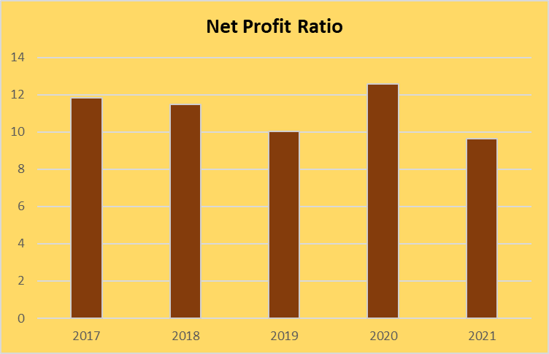

**INTREPRETATION:**

* It shows the efficiency of business as the net profit in 2017 it was 11.84 and it has fluctuating from 2018 to 2021.
* Then it decreases to 10.05 in the year 2019. So, this shows that the company has to increase the net profit has reducing the expenses.
* In the year 2021 there is a decrease in the ratio to 9.62.

**GROSS PROFIT RATIO**

Gross profit margin (GP ratio) is a financial statistic that divides a company's gross profit by its total net sales to determine its performance and efficiency. By multiplying the result by 100, the gross profit ratio can also be expressed as a percentage. Gross profit percentage or gross profit margin is used.

Gross profit = Gross profit / (Net sales × 100)

**Table showing gross profit ratio**

**(In crores)**

|  |  |  |  |
| --- | --- | --- | --- |
| **Year** | **Gross profit** | **Net sales** | **Gross profit ratio** |
| 2017 | 6578.19 | 28500.46 | 23.08 |
| 2018 | 6801.63 | 32230.49 | 21.10 |
| 2019 | 7500.32 | 33650.94 | 22.28 |
| 2020 | 8294.16 | 28836.09 | 28.76 |
| 2021 | 9668.7 | 30800.62 | 31.39 |

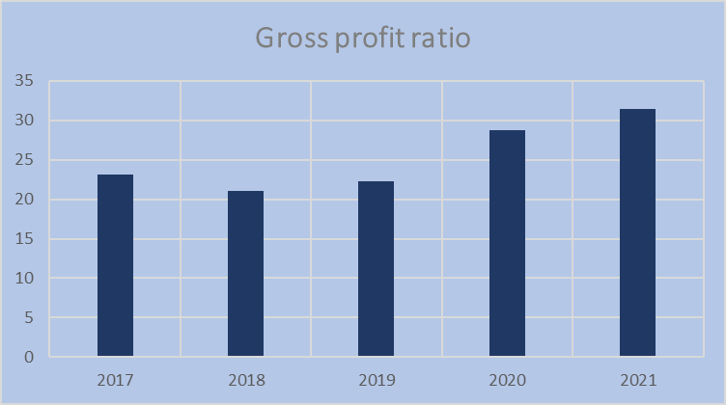

**INTREPRETATION**

* A bigger gross profit margin suggests that a business can profitably sell its products.
* The Gross Profit Ratio position of Bellad Motors Private Limited Ltd. is shown in the table above. The Gross Profit Ratio ranged from 23.08 to 31.39 over the study period 2017-2021.

**EXPENSES RATIO**

The expenditure ratio (expense to sales ratio) is used to assess the relationship between a single cost or a group of costs and sales. The spending ratio is established by dividing a given cost or collection of costs by net sales. It is expressed in percentages.

Expense ratio = total expenses / net sales *100

**Table 5 showing Expenses ratio**

**(In crores)**

|  |  |  |  |
| --- | --- | --- | --- |
| **Year** | **Total Expenses** | **Net Sales** | **Expenses ratio** |
| 2017 | 24364.43 | 28500.46 | 85.48 |
| 2018 | 27512.15 | 32230.49 | 85.36 |
| 2019 | 29331.06 | 33650.94 | 87.16 |
| 2020 | 25718.11 | 28836.09 | 89.18 |
| 2021 | 27480.09 | 30800.62 | 89.21 |

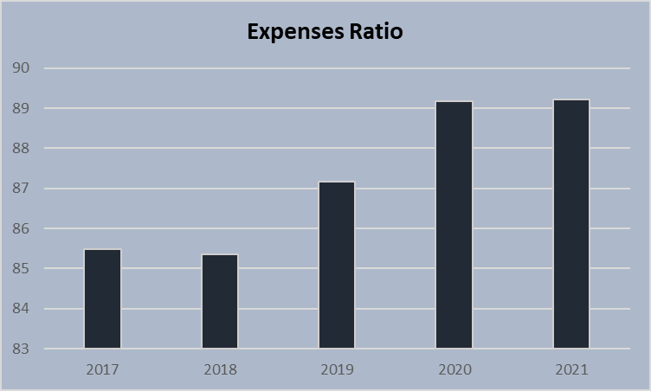

**INTREPRETATION:**

* As a result, the corporation must cut costs. There are many types of expenditure ratios, including gross expense ratio and net expense ratio.
* Expenses should be limited to a minimum rather than a maximum. In 2017, the figure was 85.48, and it is expected to rise from 2019 to 2021.

**RETURN ON CAPITAL EMPLOYED**

Return on capital employed is a profitability ratio that compares net operating profit to capital employed to assess how effectively a business can make profit from its capital spent.

EBIT/capital employed Equals return on capital employed

Total assets less current liabilities equals capital used.

**Table 6 showing Return on Capital Employed**

**(In crores)**

|  |  |  |  |
| --- | --- | --- | --- |
| **Year** | **EBIT** | **Capital Employed** | **Return on Capital Employed** |
| 2017 | 4658.46 | 10600.93 | 44.00 |
| 2018 | 5244.16 | 12395.48 | 42.35 |
| 2019 | 5010.73 | 13510.83 | 37.15 |
| 2020 | 3896.32 | 14773.27 | 26.52 |
| 2021 | 3900.38 | 16050.83 | 24.43 |

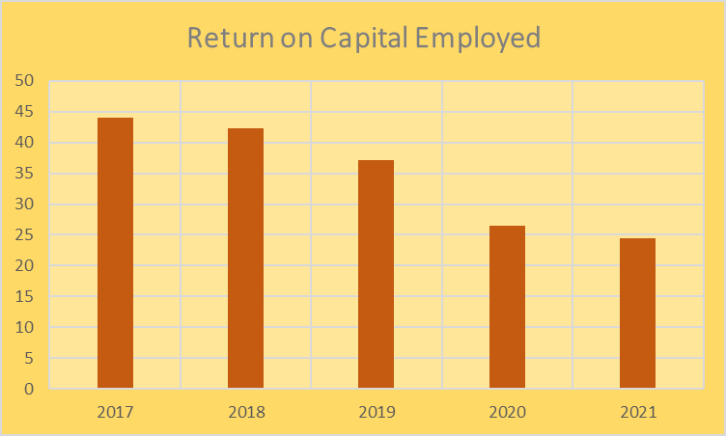

**INTREPRETATION**

* The return on capital employed in 2017 it was 44 and it has decreasing in 2018 was 42.35. Then it decreasing trends from 2019 to 2021. It shows the return capital employed decreased.
* so company has to maintain the capital employed in future growth.

**RETURN ON ASSETS**

Return on assets is a measure of a company's profitability in proportion to its total assets. Return on assets reflects how successful management is in earning income from its assets. The return on assets may be computed using a formula.

Return on assets = net income\ total assets

**Table 7 showing Return on Assets**

**(In Crores)**

|  |  |  |  |
| --- | --- | --- | --- |
| **Year** | **Net Income** | **Total Assets** | **Return On Assets** |
| 2017 | 337674 | 14694.26 | 22.98 |
| 2018 | 369592 | 16738.80 | 22.08 |
| 2019 | 338358 | 17641.19 | 19.18 |
| 2020 | 363174 | 18749.33 | 19.37 |
| 2021 | 296293 | 22161.05 | 13.37 |

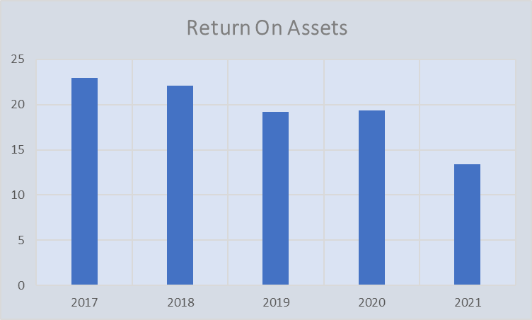

**INTREPRETATION**

* This demonstrates that the company's assets have not been put to work to create profits..
* The overall asset return In 2017, the rate of return on assets was 22.98 percent, with falling trends from 2018 to 2021.

**TOTAL ASSETS TURNOVER RATIO**

The ratio of a company's sales to its assets is known as the asset turnover ratio. It's an efficiency ratio that assesses how successfully a corporation utilises its assets to earn money.

Total assets turnover ratio = net sales / total assets

**Table 8 showing total assets turnover ratio**

**(In crores)**

|  |  |  |  |
| --- | --- | --- | --- |
| **Year** | **Net Sales** | **Total Assets** | **Total assets turnover ratio** |
| 2017 | 28500.46 | 14694.26 | 1.93 |
| 2018 | 32230.49 | 16738.80 | 1.92 |
| 2019 | 33650.94 | 17641.19 | 1.90 |
| 2020 | 28836.09 | 18749.33 | 1.53 |
| 2021 | 30800.62 | 22161.05 | 1.38 |

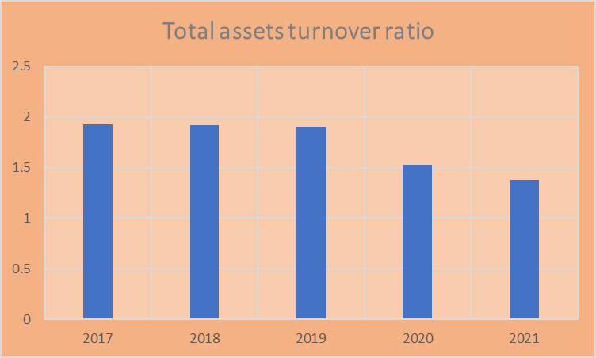

**INTERPRETATION:**

* In 2017, the asset turnover ratio was 1.93. Next, from 2018 to 2021, it will display declining models.
* Low ratios indicate that the company is not utilizing its assets effectively and is more prone to maintenance or production problems.
* This ratio assesses how well a company utilizes its assets to create revenue, with a greater ratio always being preferable.

**PROPRIETARY RATIO**

The ownership ratio (also known as the net worth ratio or equity ratio) is used to assess the stability of a firm's capital structure. Divide the shareholder's equity by the total assets to compare. Shareholder money / total direct assets = ownership ratio

**Table 9 showing proprietary Ratio**

**(In crores)**

|  |  |  |  |
| --- | --- | --- | --- |
| **Year** | **Shareholder’s fund** | **Total tangible assets** | **Proprietary ratio** |
| 2017 | 10111.29 | 4310.73 | 2.34 |
| 2018 | 11768.88 | 4485.89 | 2.62 |
| 2019 | 12857.12 | 4477.53 | 2.87 |
| 2020 | 14136.40 | 5976.00 | 2.36 |
| 2021 | 15198.43 | 5698.15 | 2.66 |

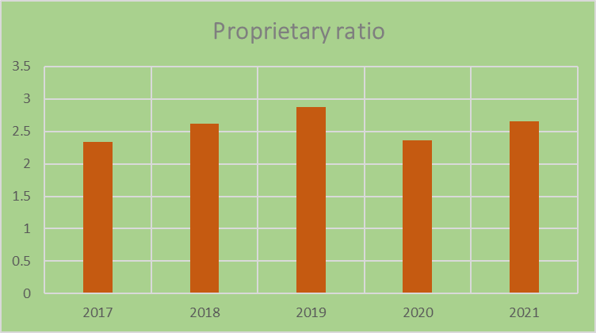

**INTREPRETATION**

* In 2017, the proprietary ratio was 2.34, and it has risen since then. Then, from 2018 to 2021, it will be on an upward trend. It demonstrates that in the year 2019, the proprietary ratio increased somewhat.
* A higher ownership ratio, on the other hand, indicates a firm financial position and better security for creditors; The low ratio, on the other hand, indicates that the company’s operations are already significantly dependent on debt.
* The proprietary ratio depicts the contribution of shareholders to the company's total capital.

**COMPARATIVE BALANCE SHEET OF BELLAD MOTORS PRIVATE LTD (In crores)**

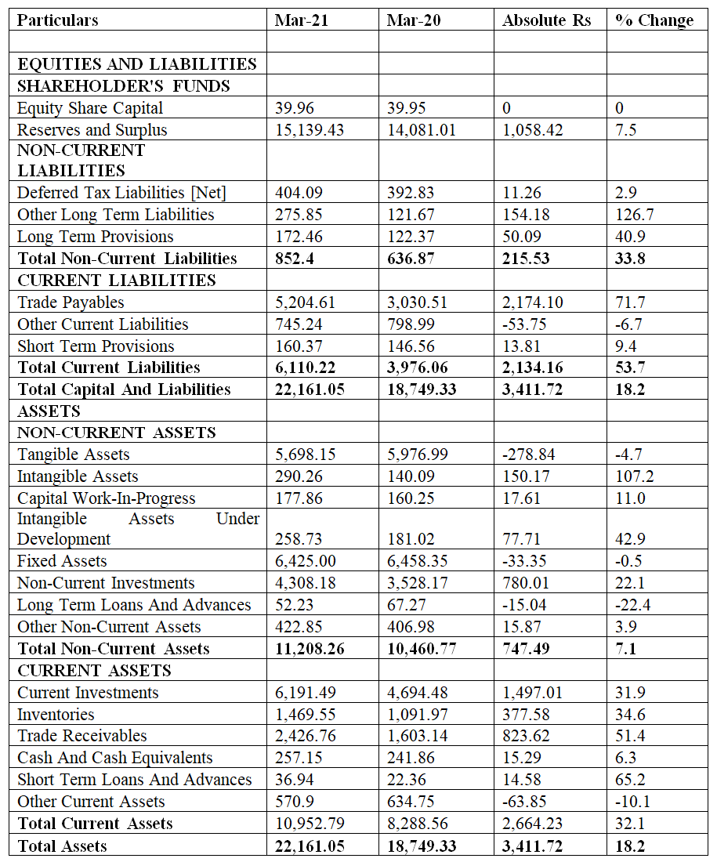

**COMPARATIVE INCOME STATEMENT BELLAD MOTORS PRIVATE LIMITED (In Crores)**

|  |  |  |  |  |
| --- | --- | --- | --- | --- |
| **Particulars** | **Mar 21** | **20-Mar** | **Absolute changes RS** | **% of Changes** |
| **INCOME** |  |  |  |  |
| Revenue From Operations [Gross] | 30,303.53 | 28,408.43 | 1,895.10 | 6.67 |
| Less: Excise/Sevice Tax/Other Levies | 0 | 0 | 0.00 | 0.00 |
| **Revenue From Operations [Net]** | **30,303.53** | **28,408.43** | **1,895.10** | **6.67** |
| Other Operating Revenues | 497.09 | 427.66 | 69.43 | 16.23 |
| Total Operating Revenues | 30,800.62 | 28,836.09 | 1,964.53 | 6.81 |
| Other Income | 579.85 | 778.34 | -198.49 | -25.50 |
| **Total Revenue** | **31,380.47** | **29,614.43** | **1,766.04** | **5.96** |
| **EXPENSES** |  |  |  |  |
| Cost Of Materials Consumed | 21,875.33 | 19,867.19 | 2,008.14 | 10.11 |
| Purchase Of Stock-In Trade | 30.46 | 0 | 30.46 | 0.00 |
| Changes In Inventories Of FG, WIP And Stock-In Trade | -143.46 | -169.78 | 26.32 | -15.50 |
| Employee Benefit Expenses | 1,898.72 | 1,841.70 | 57.02 | 3.10 |
| Finance Costs | 21.84 | 22.02 | -0.18 | -0.82 |
| Depreciation And Amortization Expenses | 676.87 | 817.96 | -141.09 | -17.25 |
| Other Expenses | 3,120.33 | 3,339.02 | -218.69 | -6.55 |
| **Total Expenses** | **27,480.09** | **25,718.11** | **1,761.98** | **6.85** |
| Profit/Loss Before Exceptional, ExtraOrdinary Items And Tax | 3,900.38 | 3,896.32 | 4.06 | 0.10 |
| Exceptional Items | 0 | 677.37 | -677.37 | -100.00 |
| **Profit/Loss Before Tax** | **3,900.38** | **4,573.69** | **-673.31** | **-14.72** |
| Tax Expenses-Continued Operations |  |  | 0.00 | 0.00 |
| Current Tax | 924.92 | 1,084.11 | -159.19 | -14.68 |
| Deferred Tax | 11.26 | -143.68 | 154.94 | -107.84 |
| **Total Tax Expenses** | **936.18** | **940.43** | **-4.25** | **-0.45** |
| Profit/Loss After Tax and Before Extraordinary Items | 2,964.20 | 3,633.26 | -669.06 | -18.41 |
| Profit/Loss from Continuing Operations | 2,964.20 | 3,633.26 | -669.06 | -18.41 |
| Profit/Loss For The Period | 2,964.20 | 3,633.26 | -669.06 | -18.41 |

**BELLAD MOTORS PRIVATE LIMITED LTD COMMON SIZE BALANCE SHEET (Rs in Crores)**

|  |  |  |  |  |
| --- | --- | --- | --- | --- |
| **Particulars** | **Mar-21** | **Common size%** | **Mar-20** | **Common size%** |
|  |  |  |  |  |
| **EQUITIES AND LIABILITIES** |  |  |  |  |
| **SHAREHOLDER'S FUNDS** |  |  |  |  |
| Equity Share Capital | 39.96 | 0.2 | 39.95 | 0.2 |
| Reserves and Surplus | 15,139.43 | 68.3 | 14,081.01 | 75.1 |
| **NON-CURRENT LIABILITIES** |  |  |  |  |
| Deferred Tax Liabilities [Net] | 404.09 | 1.8 | 392.83 | 2.1 |
| Other Long-Term Liabilities | 275.85 | 1.2 | 121.67 | 0.6 |
| Long Term Provisions | 172.46 | 0.8 | 122.37 | 0.7 |
| **Total Non-Current Liabilities** | **852.4** | 3.8 | **636.87** | 3.4 |
| **CURRENT LIABILITIES** |  |  |  |  |
| Trade Payables | 5,204.61 | 23.5 | 3,030.51 | 16.2 |
| Other Current Liabilities | 745.24 | 3.4 | 798.99 | 4.3 |
| Short Term Provisions | 160.37 | 0.7 | 146.56 | 0.8 |
| **Total Current Liabilities** | **6,110.22** | 27.6 | **3,976.06** | 21.2 |
| **Total Capital and Liabilities** | **22,161.05** | 100.0 | **18,749.33** | 100.0 |
| **ASSETS** |  |  |  |  |
| **NON-CURRENT ASSETS** |  |  |  |  |
| Tangible Assets | 5,698.15 | 25.7 | 5,976.99 | 31.9 |
| Intangible Assets | 290.26 | 1.3 | 140.09 | 0.7 |
| Capital Work-In-Progress | 177.86 | 0.8 | 160.25 | 0.9 |
| Intangible Assets Under Development | 258.73 | 1.17 | 181.02 | 1.0 |
| Fixed Assets | 6,425.00 | 28.99 | 6,458.35 | 34.4 |
| Non-Current Investments | 4,308.18 | 19.44 | 3,528.17 | 18.8 |
| Long Term Loans And Advances | 52.23 | 0.24 | 67.27 | 0.4 |
| Other Non-Current Assets | 422.85 | 1.91 | 406.98 | 2.2 |
| **Total Non-Current Assets** | **11,208.26** | **50.58** | **10,460.77** | **55.8** |
| **CURRENT ASSETS** |  |  |  |  |
| Current Investments | 6,191.49 | 27.94 | 4,694.48 | 25.0 |
| Inventories | 1,469.55 | 6.63 | 1,091.97 | 5.8 |
| Trade Receivables | 2,426.76 | 10.95 | 1,603.14 | 8.6 |
| Cash And Cash Equivalents | 257.15 | 1.16 | 241.86 | 1.3 |
| Short Term Loans and Advances | 36.94 | 0.17 | 22.36 | 0.1 |
| Other Current Assets | 570.9 | 2.58 | 634.75 | 3.4 |
| **Total Current Assets** | 10,952.79 | 49.42 | 8,288.56 | 44.2 |
| **Total Assets** | **22,161.05** | 100.00 | **18,749.33** | 100.0 |

**COMMON SIZE INCOME STATEMENT OF BELLAD MOTORS PRIVATE LIMITED(In Crores)**

|  |  |  |  |  |
| --- | --- | --- | --- | --- |
| **Particulars** | **Mar-21** | **COMMON SIZE %** | **Mar-20** | **COMMON SIZE %** |
| **INCOME** |  |  |  |  |
| Revenue From Operations [Gross] | 30,303.53 | 100 | 28,408.43 | 100 |
| Less: Excise/Service Tax/Other Levies | 0 | 0.0 | 0 | 0 |
| Revenue From Operations [Net] | 30,303.53 | 100.0 | 28,408.43 | 100 |
| Other Operating Revenues | 497.09 | 1.6 | 427.66 | 1.5 |
| **Total Operating Revenues** | **30,800.62** | **101.6** | **28,836.09** | **101.5** |
| Other Income | 579.85 | 1.9 | 778.34 | 2.7 |
| **Total Revenue** | **31,380.47** | **103.6** | **29,614.43** | **104.2** |
| **EXPENSES** |  |  |  |  |
| Cost Of Materials Consumed | 21,875.33 | 72.2 | 19,867.19 | 69.9 |
| Purchase Of Stock-In Trade | 30.46 | 0.1 | 0 | 0.0 |
| Changes In Inventories Of FG, WIP And Stock-In Trade | -143.46 | -0.5 | -169.78 | -0.6 |
| Employee Benefit Expenses | 1,898.72 | 6.3 | 1,841.70 | 6.5 |
| Finance Costs | 21.84 | 0.1 | 22.02 | 0.1 |
| Depreciation And Amortization Expenses | 676.87 | 2.2 | 817.96 | 2.9 |
| Other Expenses | 3,120.33 | 10.3 | 3,339.02 | 11.8 |
| **Total Expenses** | **27,480.09** | **90.7** | **25,718.11** | **90.5** |
| Profit/Loss Before Exceptional, Extraordinary Items And Tax | 3,900.38 | 12.9 | 3,896.32 | 13.7 |
| Exceptional Items | 0 | 0.0 | 677.37 | 2.4 |
| Profit/Loss Before Tax | 3,900.38 | 12.9 | 4,573.69 | 16.1 |
| Tax Expenses-Continued Operations |  |  |  |  |
| Current Tax | 924.92 | 3.1 | 1,084.11 | 3.8 |
| Deferred Tax | 11.26 | 0.0 | -143.68 | -0.5 |
| **Total Tax Expenses** | **936.18** | **3.1** | **940.43** | **3.3** |
| Profit/Loss After Tax And Before Extraordinary Items | 2,964.20 | 9.8 | 3,633.26 | 12.8 |
| Profit/Loss from Continuing Operations | 2,964.20 | 9.8 | 3,633.26 | 12.8 |
| Profit/Loss for The Period | 2,964.20 | 9.8 | 3,633.26 | 12.8 |

## CHAPTER – 5

## FINDINGS, CONCLUSIONS AND RECOMMENDATIONS

# FINDINGS

* The current ratio is used to estimate the relationship between current assets and current liabilities. As a general rule, the current ratio of 2: 1 is that the current ratio performance in 2017 was 1.8 percent, increased to 2.0 percent in 2018, but decreased to 1.7 percent in 2021.
* Hero MotoCorp Ltd's Gross Profitability Ratio (GPR). During the 2017-2021 research period, the gross profit ratio ranged from 23.08 to 31.39. A large gross profit margin indicates that the company can sell its products profitably.
* Costs should be minimized rather than maximized; In 2017, it was 85.48 and it is projected to increase from 2019 to 2021. As a result, the company has to cut costs. There are a variety of cost ratios, including the gross cost ratio and the net cost ratio.
* In 2017, the return on capital was 44, but in 2018 it dropped to 42.35. After that, from 2019 to 2021, it will be on a downward trend. Shows that the capital used for the return is reduced. As a result, the company must secure the money invested in future expansion.
* In 2017, return on total assets was 22.98 per cent, with declining trends from 2018 to 2021. This indicates that the company assets have not been put into operation to generate revenue.
* The liquidity ratio is one to one. The liquidity ratio of the company is shown in the table above. It rose to 1.6 in 2017 and 1.8 from 2018 to 2020. After that it fell to 1.5 by 2021. A 1: 1 liquidity ratio is adequate. The company liquidity ratio is awesome.
* Cash position ratio is the ratio of current liabilities to current assets. The optimal range is between 0.2 and 0.5. In the table above, the company’s cash position remained stable at 0.03 percent from 2017 to 2019, and then increased to 0.06 percent in 2020.
* This shows the company’s potential as net profit fluctuated from 11.84 in 2017 and from 2018 to 2021. Then, in 2019, it dropped to 10.05. As a result, the company's net profit should increase while reducing costs. In 2021, the ratio dropped to 9.62.
* In 2017, the asset turnover ratio was 1.93. Then, from 2018 to 2021, declining patterns emerged.
* In 2017, the ownership was 2.34 per cent and it has been growing ever since. Then, from 2018 to 2021, it will be on an upward trend. This shows that the ownership percentage has increased somewhat in 2019.
* Propritory ratio describes the shareholder's contribution to the company's total capital. As a result, a higher ownership ratio indicates a stronger financial position of the company and greater security of creditors. The low ratio indicates that the company’s operations are already highly dependent on debt.
* Analysis of Comparative Revenue Statement As can be seen from the above, the sales volume of the company increased by 1895.10 cores or 6.67% over the previous year. Although other incomes are down 25.50 percent, the difference in absolute terms does not affect total revenue.
* A larger ratio is usually more profitable because it reflects how effectively the company uses its assets to generate revenue. Higher turnover rates indicate that the company is making good use of its assets. Low ratios indicate that the company is not making the best use of its resources and has more management or production issues.
* Examining the ‌ Standard Income Statement the company performed almost identical with the previous year's performance. Operating expenses fell 0.80% on sales, resulting in a 0.80% increase in operating profit over the previous year. Net PBDT was down 0.05 percent compared to last year's sales. PBT also increased by 16.1% compared to sales. As mentioned earlier, the company benefits from a reduction in operating costs.
* Balance Sheet Analysis of Standard Size As a result of the above, non-current assets increased by 55.8% compared to the previous year. Although current assets have grown in absolute terms, their percentage is down 4.2 percent from last year. Current responsibilities are also shown In a similar pattern, with a decrease of 6 percent. As a result, the financial position of the company is similar to the previous year.
* Total revenue rose 5.96 per cent, but the company's PBT fell 673.31 cores, or 14.72 per cent, compared to the previous year. Financing costs fell 0.82 percent, while other expenses fell 6.55 percent. Compared to last year, staff costs increased by 3.10%. As a result the company was able to maintain profitability over the previous year.
* Comparative balance sheet analysis As can be seen from the above, the company’s current liabilities increased by 53.7 per cent over the previous year. Trade payments rose 2174.10 Corers, indicating that the company's credibility has improved over the current year. The company's current assets also increased by 2,664 crores last year.

# RECOMMENDATIONS

* Bellad Motors Private Limited performance throughout the study period was strong during the first four years, and the company was efficient in maintaining financial capacity to support all of its development and diversification plans.
* The firm should preserve liquid assets in order to strengthen its liquidity position in the future, as well as take the required actions to boost the company's earning capability.
* They should boost the company's short-term liquidity, which will assist them satisfy their existing obligations.
* The following were the recommendations made to the company:
* The firm has implemented the appropriate plan to increase net profit in the next years.

# CONCLUSIONS

Improving the financial performance of the company. One of these great companies is Bellad Motors Private Limited.

During the year, the company was able to expand its sales and profits. This improved the company's operations. The net profit margin has improved, indicating that the company can manage costs more efficiently. The company's current assets are sufficient to cover its current liabilities. Bellad Motors Private Limited. Largest market share in the two-wheeler market. As planned revenues increased, the company was a profitable endeavor from a shareholder perspective. Compared to previous years, earnings per share have also increased. In general, the company has been successful in meeting the demands of shareholders and customers.

In terms of financial performance, a company's success is determined by how external financial markets view and respond to it. The world of Khatib management is more complex and fast today. Financial managers need to understand how to make productive judgments while avoiding the useless ones.

# BIBLIOGRAPHY

**BOOKS AND ARTICLES**

* Account for managers/ Thakur Publication/ Reference Page no4.5-9.4 • Introductory accounts and finance for non-accountants/ D. K Chatterjee/ Himalaya publishing house/ page no6.8,6.10–6.16
* Financial Management/Dr.N.M. Vechalkar/ Nirali prakashan/ Reference page no7.13–7.23,4.3-4.4
* Financial Management/S.C. Kuchhal/ Chaitanya Publishing House/ 16th Edition manufacture 2007/ Reference page no7.2–7.4,7.18,7.21
* Financial Management, khan and Jain

**WEBSITES**

* [www.oppappers.net](http://www.oppappers.net)
* [www.scribd.com](http://www.scribd.com)
* [www.slidesshare.net](http://www.slidesshare.net)
* https//planergy.com/blog/ratio-analysis-of-financial-statements/
* https//en.wikipedia.org/wiki/Financial_statement_analysis
* Financial Management – I.M.Pandey .
* [www.Moneycontrol.com](http://www.Moneycontrol.com).

# ANNEXURES

**Balance sheet of Bellad Motors Private Limited LTD for the year 2017, 2018, 2019, 2020 & 2021**

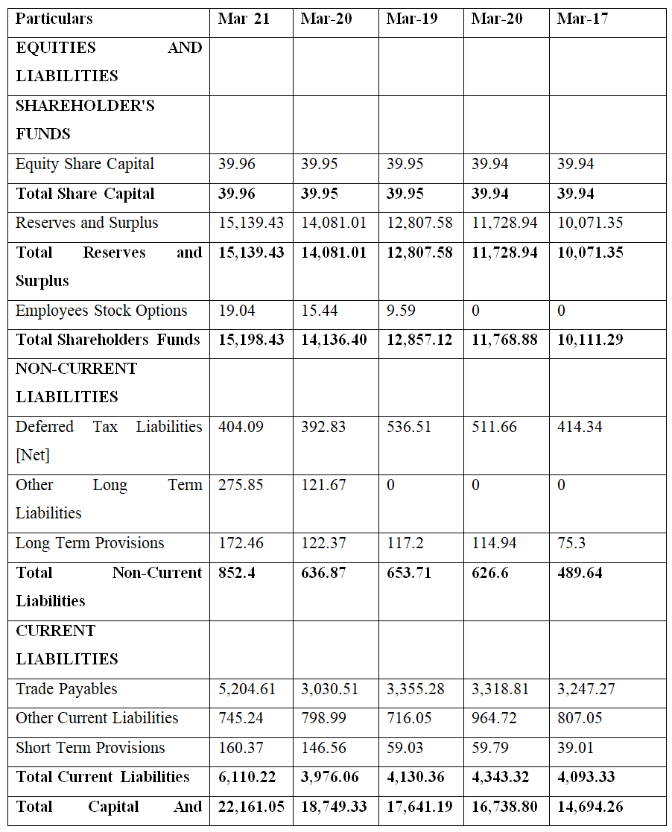

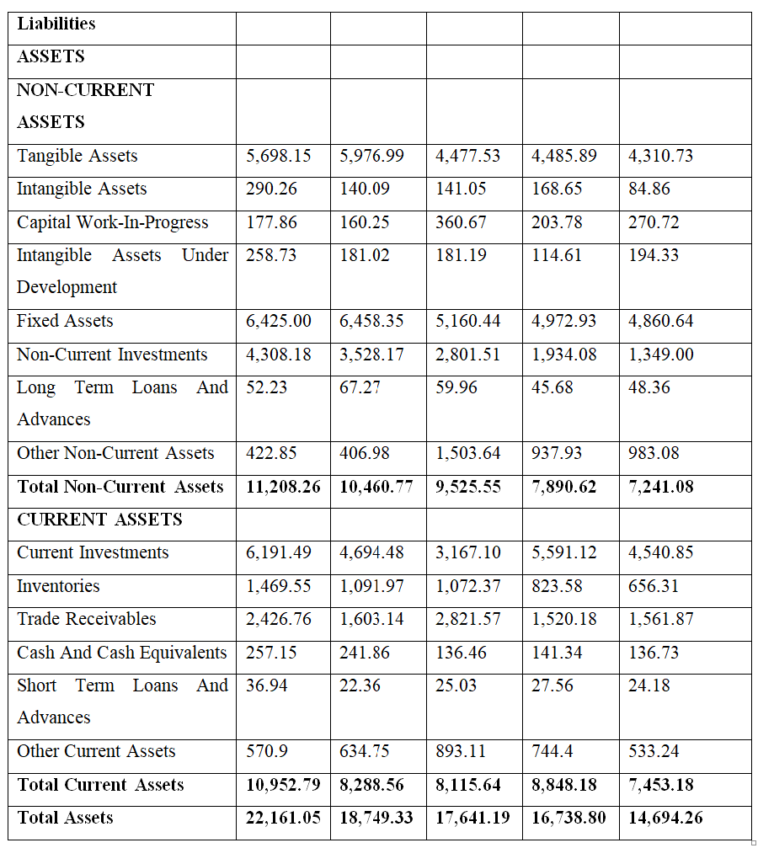

**Bellad Motors Private Limited profit and loss account for the years 2017, 2018, 2019, 2020, and 2021**

